San Francisco Collaborative Partnering Steering Committee
Meeting #7 Report
June 7, 2018

San Francisco Public Library Latino Room
100 Larkin Street
San Francisco, CA

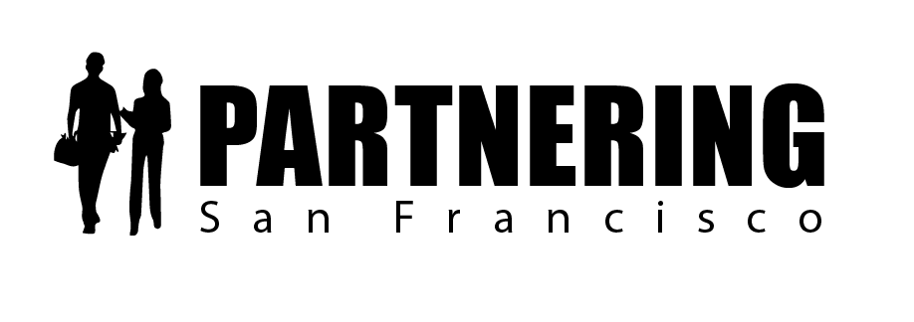

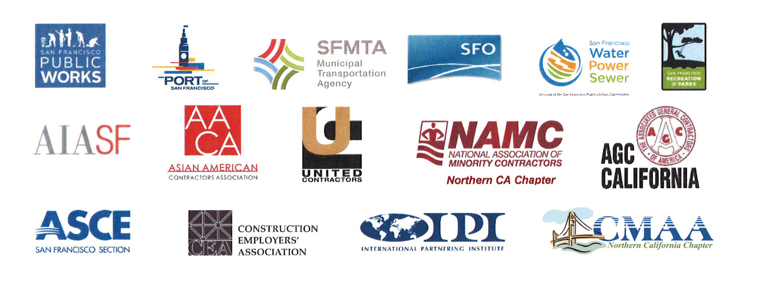
Rob Reaugh
Facilitator
925-487-2404
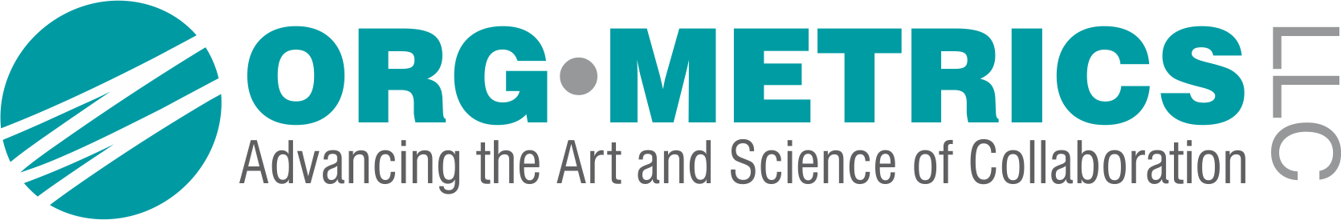robreaugh@orgmet.com

San Francisco Collaborative Partnering Steering Committee
Meeting #7 Report
June 7, 2018
As recorded on the flip charts

SFCPSC DISCUSSION – The Partnering Field Guide Implementation Plan
Critical Next Steps:
The SFCPSC discussed the implementation plan for the launch of the new GC’s, Partnering Specifications and Partnering Field Guide.

Step #1: San Francisco Partnering Field Guide Launch
a. We will begin sharing the new draft San Francisco Partnering Field Guide with industry by July 20th.
We will launch the new San Francisco Partnering Field Guide program at the SF City/Contractors Liaison Meeting on August 22.
b. We will update the verbiage and place a disclaimer on the sample Integrated Dispute System in Appendix L (p. 83-86).
c. We will update the Partnering Champions page (rear inside cover).

Step #2: We will support the launch of the new partnering program
a. The six directors will develop a joint letter to support the launch of the new Partnering Field Guide, Specifications, Training Program and Awards Program.
Who: Rob and Jen will draft and distribute for signature
b. Public Works will develop a new one-page piece to support the launch of a new program.
c. UCON, AGC, and CEA will develop a joint bulletin to launch the new program.
Who: Emily and Jen will set up a call
c. We will ask our staffs to mention Partnering and the new Partnering Field Guide at pre-bid conferences across all departments.
When: Beginning August 22

Step #3: Coordination with the City Attorney’s Office
a. Ed Reiskin and Edgar Lopez will follow up with the City Attorney’s Office to support the acceptance of the General Conditions. We will push to complete by June 30. If additional time is required, we will update the SFCPSC.
b. We will reinstate internal meetings between City staff leadership and the City Attorney’s Office across all departments. Areas of focus include the GCs update and the need to update the MOUs and internal integrated dispute resolution.
Who: Ed and Edgar will launch the process by gathering the City Attorney reps.
c. We will start the MTA General Conditions Review by June 15.
Who: Bijan, Shahnam and Rob
d. For SFPUC, we will work with Alan to amend the GCs.
e. For SFO, Mark will share with Geoff Neumayr and Julia Katz to amend the GCs.

Step #4: Support for the Citywide Partnering Coordinator (Jen Blot)
a. MTA will provide administrative support to the Partnering Coordinator.
Who: Jen and Rob will follow up with Ed Reiskin
b. The Port of San Francisco will provide meeting and logistical support to the Partnering Coordinator.
Who: Jen and Rob will follow up with Rod
PARTNERING ENHANCEMENT PROPOSALS
The SFCPSC focused on two Partnering Enhancement Proposals (PEPs) and signed two.
PEP 2.3.3. Partnering Newsletter and PEP 1.1.1 Partnering Training (signed with revisions).

Performance Measures
Co-Chairs: Edgar Lopez and Jim Pappas
The Performance Measures Subcommittee’s PEP 2.3.3 Partnering Newsletter was signed by the SFCPSC on 6/7/18.

PEP 2.3.3 – Partnering Newsletter
Performance Measures – Signed by SFCPSC 6/7/18
Problem Statements and Current Practice
There is currently no forum to recognize project teams that are successfully using partnering to improve project outcomes as the project progresses.

2.3.3 How do we recognize construction project teams that are using partnering successfully as the projects are being built?
How do we inform City and industry of new programs and initiatives related to the partnering program?

Discussion:
- We need to add the tagline “Working together to make the City and County of San Francisco the Owner of Choice” to the newsletter
- We need to provide success stories to the Partnering Coordinator with the goal of having ten (10) stories to select from each quarter

Resources Required and Implementation Plan
The subcommittee will develop an online partnering newsletter and use the existing contractor liaison e-mail list as a foundation for forming a newsletter distribution list. The Partnering Coordinator will develop the newsletter and members of the SFCPSC will provide success stories and content ideas.

Implementation Plan
- SFCPSC signed PEP 2.3.3 on 6/7/18.
- We will introduce and distribute the Partnering Newsletter at the August 22 SF City/Contractors Liaison Meeting.

NOTE: See Attachment 1 for signed PEP 2.3.3, which includes the sample newsletter

Education and Training Subcommittee Updates
Co-Chairs: Bijan Ahmadzadeh and Ed Moore

The Education and Training Subcommittee developed and signed PEP 1.1.1 Partnering Training, which was signed (with amendments) by the SFCPSC on 6/7/18.

PEP 1.1.1 – Partnering Training
Education and Training – Signed (with amendments) by SFCPSC
Problem Statements and Current Practice
Currently, the project managers (PMs), construction managers (CMs) and resident engineers (REs) delivering projects for City departments and the contractors and subcontractors they work with often do not have a mutual understanding of how to implement and maximize the partnering process. The result is that the application of partnering is inconsistent, and not all departments see the return on investment they can reap from fully implementing the partnering process.

1.1.1 How do we educate City and industry staff on the benefits of partnering?
How can we develop a partnering culture that allows us to deliver construction projects faster and more efficiently?
How do we educate our field teams so they focus on what is fair, while maintaining project requirements and allowing the contractor to be profitable?
How do we train our department and industry supervisors and executives to support the partnering culture we are trying to develop?
Recommendation:
We will develop a training program based on the new Partnering Field Guide that incorporates all the new policies and practices developed by the SFCPSC. The training program can be funded by each department through as-needed contracts and through the project partnering allowance.

Discussion:
- The Training Task Group (Uday Prasad, Kevin Wagner and Mark Costanzo) will develop a more complete implementation plan to present by October 1. The Task Group must:
  - Develop a registration system
  - Develop a training certification for the individuals who have been trained
  - Develop a certification database
  - Develop a bonus point structure for professional services and qualifications-based selection
  - Finalize the funding sources: The current plan is to use as-needed contracts to fund $60-80,000 and the project partnering allowance to fund the training

Resources Required:
The SFCPSC Partnering Facilitator and Partnering Coordinator will work with the Training Task Group to develop the draft training program and work with the Education and Training Subcommittee to vet the content, marketing and funding vehicles.

Implementation Plan
- SFCPSC signed PEP 1.1.1 (with amendments) on 6/7/18.
- The Training Task Group will complete the updated implementation plan by 10/1/18.

NOTE: See Attachment 2 for signed PEP 1.1.1

WHAT IS STANDING OUT TO YOU?
The members of the SFCPSC were asked “What stood out to you today?”
(Repeated answers have multiple checkmarks -)
- Great momentum -
- Good progress on the implementation -
- I’m inspired – we made good progress -
- Good to get back with the group and make progress -
- Good progress on the GC’s and specs -
- We need consistent attendance and to flush out the roster -
- We need to keep pushing!
- We like the newsletter and progress on the awards program – thank you Jen!

FOLLOW UP STEERING COMMITTEE MEETINGS
Planned Fall 2018 | 9 a.m. – noon | To be determined

UPCOMING STEERING COMMITTEE EVENT
Inaugural San Francisco Collaborative Partnering Awards Ceremony
War Memorial Green Room 9/25/18 10:00 a.m. – noon

UPCOMING SUBCOMMITTEE MEETINGS
Performance Measures | 8/29/18  10/5/18  11/28/18 | 1:00 p.m. – 2:30 p.m.  1:00 p.m. – 2:30 p.m.  1:00 p.m. – 2:30 p.m. | 30 Van Ness 4th Floor Main Conf Room  30 Van Ness 4th Floor Main Conf. Room  30 Van Ness 4th Floor Main Conf. Room
Education & Training | 8/23/18  10/10/18  11/29/18 | 1:00 p.m. – 2:30 p.m.  1:00 p.m. – 2:30 p.m.  1:00 p.m. – 2:30 p.m. | 1 S. Van Ness 3rd Floor N. Beach Conf. Room  1 S. Van Ness 3rd Floor N. Beach Conf. Room  1 S. Van Ness 3rd Floor N. Beach Conf. Room

ATTENDEES
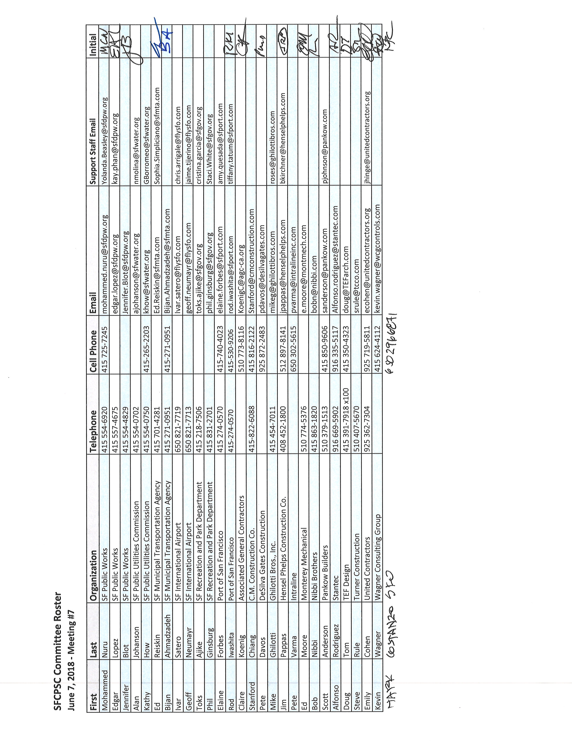

PARTNERING – A MEDIATIVE PROCESS

California Evidence Code

§ 1119. Mediation confidentiality

1119. Except as otherwise provided in this chapter:

(a) No evidence of anything said or any admission made for the purpose of, in the course of, or pursuant to, a mediation or a mediation consultation is admissible or subject to discovery, and disclosure of the evidence shall not be compelled, in any arbitration, administrative adjudication, civil action, or other noncriminal proceeding in which, pursuant to law, testimony can be compelled to be given.

(b) No writing, as defined in Section 250, that is prepared for the purpose of, in the course of, or pursuant to, a mediation or a mediation consultation, is admissible or subject to discovery, and disclosure of the writing shall not be compelled, in any arbitration, administrative adjudication, civil action, or other noncriminal proceeding in which, pursuant to law, testimony can be compelled to be given.

(c) All communications, negotiations, or settlement discussions by and between participants in the course of mediation or a mediation consultation shall remain confidential.

THANK YOU FOR LETTING ME BE OF SERVICE

OrgMetrics LLC works with construction teams who want to prevent or resolve disputes
and with leaders who want to improve their organizations.

Our Mission is to create the most successful construction teams in the world!

ORG•METRICS LLC
291 McLeod Street
Livermore, CA 94550

Phone: (925) 449-8300
Email: robreaugh@orgmet.com
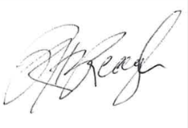
Please call if I can help in any way,

Rob Reaugh

