San Francisco Collaborative Partnering Steering Committee
Education & Training Meeting #3 Report
June 16, 2017

San Francisco Municipal Transportation Agency
3rd Floor Civic Center Conference Room
1 South Van Ness Ave
San Francisco, CA

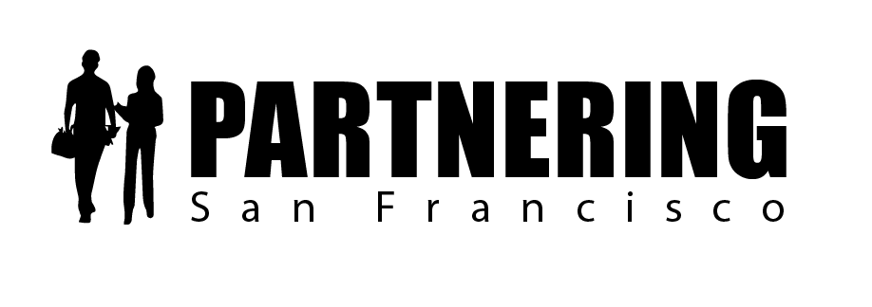

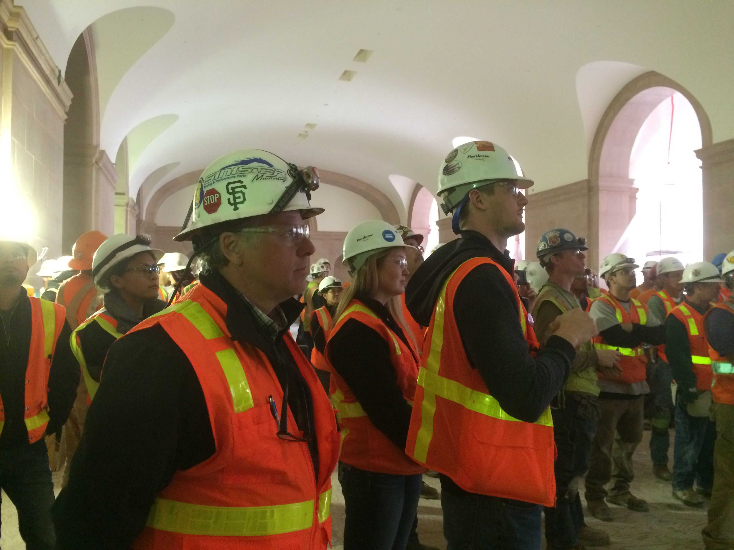
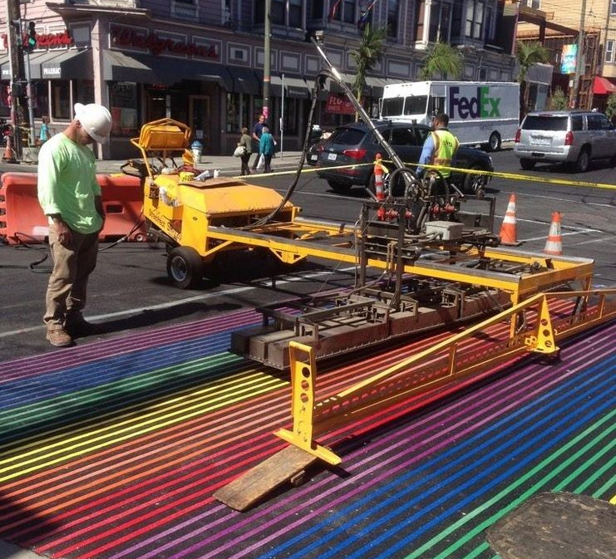

Rob Reaugh
Facilitator
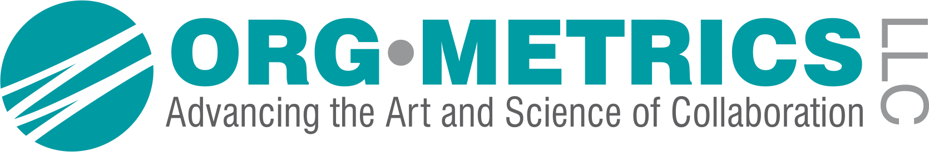925-487-2404
robreaugh@orgmet.com

San Francisco Collaborative Partnering Steering Committee
Education & Training Subcommittee Meeting #3
June 16, 2017

As recorded on the flip charts

ACTION PLAN AND FOLLOW-UP ITEMS

  - The subcommittee approved PEP 1.2.4-Integrated Dispute System and will present the signed PEP to the Steering Committee on June 28th. In the PEP, we agreed:
- That direct negotiation and Partnering are catching and preventing the vast majority of project issues, but there are still a few issues per year that are becoming Government Claims.
- To add Facilitated Issue Resolution as an optional tool that can help with these issues. Project teams can add it to the Issue Resolution Ladder during the partnering kick-off section. The fees for the process will be split 50/50 like the partnering process.
- Facilitated Issue Resolution could be used by teams using the DRA or DRB (SFPUC or SFMTA) if the team does not agree with the DRA or DRB ruling.
- That Twenty (20) days could be added to the NOPC resolution process on an issue that is being resolved through Facilitated Issue Resolution.
- The person conducting the Facilitated Issue Resolution can either be your Partnering Facilitator or a professional neutral with substantive knowledge in construction.

  - The subcommittee approved PEP 1.4.2-Interdepartmental Project MOUs and will present the signed PEP to the Steering Committee on June 28th. In the PEP (and future MOUs), we agreed:
- The Lead Agency will be identified.
- The Partnering processes and procedures of the Lead Agency would be used.
- The Interdepartmental MOUs would include reference to the issue resolution process contained in the updated Partnering Field Guide.

3.1 The subcommittee discussed PEP 1.4.1-Interdepartmental Issue Resolution and would like additional time to simplify the Interdepartmental Resolution Ladder and develop recommended policies and procedures.

EDUCATION AND TRAINING SUBCOMMITTEE FOLLOW-UP MEETINGS
Our next face-to-face meetings will be held:
- Monday August 7, 2017 9am – 10:30am – SFMTA – 3rd Floor North Beach Conference Room
- Tuesday September 26, 2017 2-3:30pm – SFMTA – 3rd Floor Civic Center Conference Room
- Friday December 8, 2017 1-2:30pm – SFMTA – 3rd Floor Civic Center Conference Room

PEP 1.2.4 Integrated Dispute System – for Signature

Success Factor 1.0: Education and Training
Issue 1.2.4 Integrated Dispute System
Problem Statement and Current Practice
Currently, each Department handles dispute resolution and claims prevention differently. Contractors and City Staff do not know what issue resolution tools are at the project team’s disposal from the outset of the project and when they can and should use them.
- How can we develop an integrated dispute system so the Issue Resolution Ladder process is directly linked to claims resolution and ultimately, claims prevention?
- How can we ensure that the Integrated Dispute System is flexible enough that each Department can determine which elements it needs based on the size and complexity of its projects?

Proposal: 1.2.4. An Integrated Dispute Resolution System
The goal of any issue resolution process is to resolve all construction project issues at the lowest appropriate level. Construction project teams are expected to resolve construction issues using informal negotiation and the Issue Resolution Ladder developed in the Partnering process.

Recommendations:
To ensure that all methods for resolving project issues are resolved prior to an issue becoming a Government Claim, we recommend that we develop an Integrated Dispute System and incorporate that system into the key Partnering documents, including the Partnering Specifications, the updated Partnering Field Guide and the relevant SF Department General Conditions (if needed).
We recommend that we add Facilitated Issue Resolution (FIR) as an optional tool to add to the Issue Resolution process to ensure that all team-controlled vehicles for issue resolution are used prior to filing for a Government Claims.

Facilitated Issue Resolution is a mediation-like process where the Partnering Facilitator (or a mutually-selected professional neutral with knowledge of construction) can be used by the team to resolve specific construction disputes. The team will decide during the kick-off Partnering meeting whether they would like to include the Facilitated Issue Resolution Process for that project.
If a team elects to use the Facilitated Issue Resolution process for an issue that has become a Notice of Potential Claim (NOPC), they will be given up to 20 additional days to resolve it.
The project team can include the option of Facilitated Issue Resolution during the kick-off Partnering meeting when they are developing the Partnering Maintenance Plan and the Issue Resolution Ladder. The fees associated with Facilitated Issue Resolution will be split 50/50 between the SF Department and the contractor.

Integrated Dispute System
For SF Public Works, SFO International Airport, Port of SF, and SF Rec and Park

Sample Issue Resolution Ladder with Optional FIR
Team Level | Awarding City Department | Contractor | Time to Elevate
I | Inspector or Resident Engineer | Foreman/ Superintendent | 1 day
II | Project Manager | Project Manager | 1 week
IIII | Program Manager | Area Manager | 1 week
IV | Division Manager | Operations Manager | 2 weeks
V | Deputy Department Director | Owner; President | 1 week
ADR | *Facilitated Issue Resolution  (Team is allowed to add 20 additional days to the NOPC process to resolve the issue)
*Note – The project team will discuss the optional inclusion of Facilitated Issue Resolution during the Partnering kick-off meeting. If it is used, it will be added to the Issue Resolution Ladder.

For Project Teams using a Dispute Review Advisor (DRA) / Dispute Review Board (DRB) and Facilitated Issue Resolution (FIR)
*Note – For SFPUC and SFMTA only
For construction projects who wish to use the Dispute Review Advisor (DRA) or Dispute Review Board (DRB), the Facilitated Issue Resolution process will be used if either party does not agree to a decision delivered by the DRA or DRB. (See sample Dispute System and IRL below).

Sample Issue Resolution Ladder with DRA/DRB and FIR

Team Level | Awarding City Department | Contractor | Time to Elevate
I | Inspector or Resident Engineer | Foreman/ Superintendent | 1 day
II | Project Manager | Project Manager | 1 week
IIII | Program Manager | Area Manager | 1 week
IV | Division Manager | Operations Manager | 2 weeks
V | Deputy Department Director | Owner; President | 1 week
ADR | Dispute Review Advisor (DRA) or  Dispute Review Board (DRB)
*Facilitated Issue Resolution
(Team is allowed 20 additional days once an NOPC is filed to resolve)

PEP 1.4.2 Interdepartmental MOUs – for Signature

Education and Training PEP
Issue 1.4.2 Interdepartmental MOUs
Problem Statements and Current Practice
For interdepartmental projects, City PMs, CMs, REs and contractors delivering the projects do not have a mutual understanding for what to do when a contract issue or CCO requires engagement from more than one Department. The Memoranda of Understanding (MOU) names a lead agency and describes the roles and responsibilities of the other participating SF Departments. However, each SF Department has different policies surrounding decision-making and change management, leading to a heavy learning curve for project teams that lack experience. Furthermore, although teams may use partnering to develop a project-level Issue Resolution Ladder, teams do not routinely “integrate” the partnering and issue resolution processes to include the funding Departments who will need to opine and sign off on change orders or scope changes.

- How can we improve Interdepartmental project MOUs to reflect a partnering approach to project delivery?
- How can we update policies and procedures so the implementation of interdepartmental projects becomes more consistent and easy to understand for contractors?

Proposal 1.4.2 MOUs for interdepartmental projects
We agree that the structure and content of the MOUs are not consistent between departments. Additionally, the MOUs either have no description of issue resolution or refer to general “policies”, which are not included anywhere else in the MOU.
The most common Interdepartmental project types involve:
- SFMTA (PM) and SF Public Works (CM) or SFPW providing CM/PM for SFMTA projects
- Port of San Francisco (PM) and SF Public Works (CM) or SFPW providing CM/PM for Port
- SFPUC (PM) and Public Works (CM) or SFPW providing CM/PM for SFPUC
- Recreation and Park (PM) and Public Works (CM) or SFPW providing CM/PM for Rec & Park
- SF Department of Health and Public Works (CM/PM)
- SF Fire Department and SFPW (CM/PM)

A review of MOUs for the most common project types included projects in which SF Public Works (SFPW) Construction Management (CM) services (Project Administration) or Project Management (PM) (Budget Oversight). The subcommittee also reviewed an MOU where SF Municipal Transportation Agency (SFMTA) served as the lead agency for a project involving Rec and Park and SFPW (sample below)
Dispute Resolution clause from 2014 MOU between SFMTA, Rec and Parks and SF Public Works

Recommendations:
1) Add an Issue Resolution section to all Interdepartmental Project MOUs.
• In the Issue Resolution section, we will identify the Lead Agency.
• In the Issue Resolution section, we will refer the team to the Partnering and Issue Resolution policies and procedures for the Lead Agency.
• In the Issue Resolution section, we will refer the team to the section focused on Interdepartmental projects in the updated Partnering Field Guide. This section will include a sample “Integrated Dispute Resolution Ladder” and recommended policies and procedures specific to those projects.

2) Update Field Level Partnering Guidance with new Policies and Procedures related to Interdepartmental Issue Resolution.
We need to update the current “Mini Guide to Partnering” to include a section focused on Interdepartmental Projects. This section will include a sample Issue Resolution Ladder for Interdepartmental projects issue resolution policies and procedures. It will highlight methods to support project delivery in a Partnering environment, resulting in enhanced field-level decision making, more “holistic” project delivery, and improved change-order negotiation.

Status:
- PEP 1.4.2 Reviewed and agreed by subcommittee 6/16/17
- Update Partnering field guide - 12/15/17

PEP 1.4.1 Interdepartmental Project Issue Resolution – DRAFT

Success Factor 1.0: Education and Training
Issue 1.4.1 Interdepartmental Project Issue Resolution
Problem Statements and Current Practice
Currently, the PMs, CMs and REs delivering projects for SF Departments, contractors, and designers do not have a mutual understanding for how to properly use the Issue Resolution Ladder (IRL) to resolve construction project issues for Interdepartmental projects.

- How can we teach project teams to understand and effectively develop a Partnering process for interdepartmental projects that can enhance project collaboration?
- How can adjust the IRL to speed up construction project negotiation?

Proposal 1.4.1. Issue Resolution Ladders (IRLs) for interdepartmental projects
We agree that the Issue Resolution Ladder (IRL) is a tool implemented on Partnering projects to empower the field level to make decisions and to elevate issues when either side of the ladder gets stuck.
Research on Interdepartmental projects has revealed:

The most common Interdepartmental project types involve:
- SFMTA (PM) and SF Public Works (CM) or SFPW providing CM/PM for SFMTA projects
- Port of San Francisco (PM) and SF Public Works (CM) or SFPW providing CM/PM for Port
- SFPUC (PM) and Public Works (CM) or SFPW providing CM/PM for SFPUC
- Recreation and Park (PM) and Public Works (CM) or SFPW providing CM/PM for Rec & Park
- SF Department of Health and Public Works (CM/PM)
- SF Fire Department and SFPW (CM/PM)

Common Challenges:
- Each Interdepartmental project is governed by a unique MOU, so the team is unsure of which Department’s issue resolution policies and procedures they will adhere to
- One entity will automatically elevate issues to the top executive level before the project team has an opportunity to explore and develop consensus (avoiding the “Ladder” altogether)
- Contractors rarely understand how project-level decision making takes place and it is common for these projects to lack a clear “owner/decision-maker”, delaying decision-making

Recommendations:
- We will develop a sample “Integrated Dispute Resolution Ladder” to be included in the updated Partnering Field Guide (Addendum 1)
- We will include basic definitions for the Lead Agency and Secondary Funding agencies.
- We will develop Update Field Level Partnering Guidance with new Policies and Procedures related to Interdepartmental Issue Resolution and Claims Administration

Status:
- PEP 1.4.1 Reviewed and subcommittee recommended to simplify the Integrated Issue Resolution process and develop sample policies and procedures and recommendations for Partnering
- Update PEP for review 8/1/2017
- Update Partnering field guide - 12/15/17
HOW A CHANGE BECOMES A CLAIM
During the meeting, the subcommittee reviewed the SFPW General Conditions walked through the process that progresses from a Request for Information or a Contract Change Request all the way through a Notice of Potential Claim and ultimately a Government Claim (see photos).
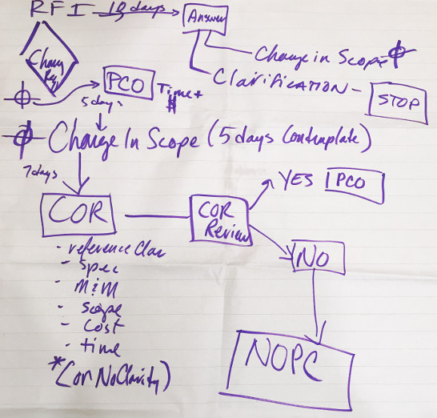

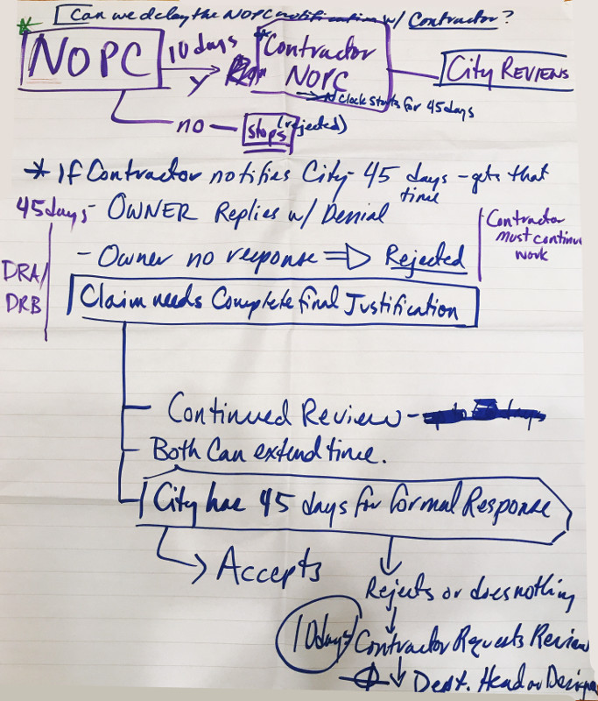

Findings:
- Change Notices can be solved as PCOs at any time by the team
- When an NOPC is submitted by the contractor, the City has 45 days to provide a formal response and no response means that the proposal is rejected. This extends beyond the Partnering IRL.
- Facilitated Issue Resolution (FIR) could provide a team-controlled forum to resolve outstanding NOPCs during construction and the additional 20 days would provide a deadline for resolution.

INCLUDING ARCHITECTURE AND ENGINEERING IN CCO DISCUSSIONS
The subcommittee also discussed that frequently, Architecture and Engineering (A&E) staff are not informed as to whether the Owner would be taking an action against the A&E until the very end of the job. The subcommittee recognized that this relates to separate contracts, but recommended that teams include Design and/or the A&E professionals in CCO discussions.
Further, it was recommended that Owner representatives include a notification clarifying whether a recovery action is being considered, resulting from the NOPC or CCO.

ATTENDEES
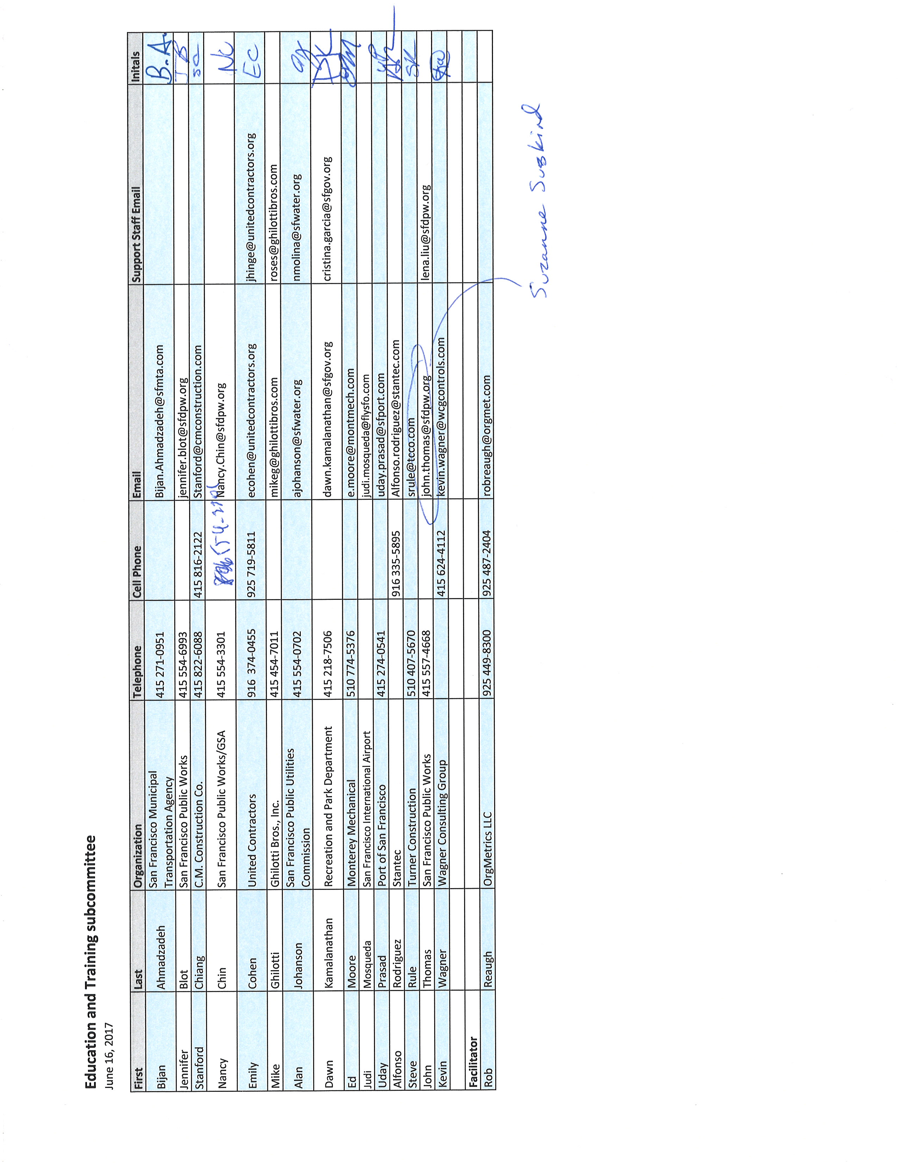

PARTNERING – A MEDIATIVE PROCESS

California Evidence Code

§ 1119. Mediation confidentiality

1119. Except as otherwise provided in this chapter:

(a) No evidence of anything said or any admission made for the purpose of, in the course of, or pursuant to, a mediation or a mediation consultation is admissible or subject to discovery, and disclosure of the evidence shall not be compelled, in any arbitration, administrative adjudication, civil action, or other noncriminal proceeding in which, pursuant to law, testimony can be compelled to be given.

(b) No writing, as defined in Section 250, that is prepared for the purpose of, in the course of, or pursuant to, a mediation or a mediation consultation, is admissible or subject to discovery, and disclosure of the writing shall not be compelled, in any arbitration, administrative adjudication, civil action, or other noncriminal proceeding in which, pursuant to law, testimony can be compelled to be given.

(c) All communications, negotiations, or settlement discussions by and between participants in the course of mediation or a mediation consultation shall remain confidential.

THANK YOU FOR LETTING ME BE OF SERVICE

ORG•METRICS LLC, celebrating its 30th year of service, works with construction teams who want to prevent or resolve disputes and with leaders who want to improve their organizations.

Advancing the Art and Science of Collaboration!
ORG•METRICS
291 McLeod Street
Livermore, CA 94550
Phone: (925) 449-8300
email: robreaugh@orgmet.com
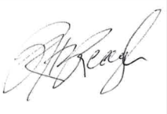
Please call if I can help in any way

Rob Reaugh

