# San Francisco Collaborative Partnering Steering Committee

Education & Training Meeting #7 Report

January 24, 2018

San Francisco Municipal Transportation Agency

3rd Floor Civic Center Conference Room

1 South Van Ness Ave

San Francisco, CA

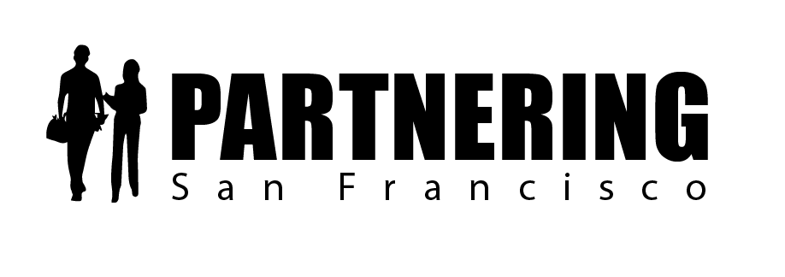

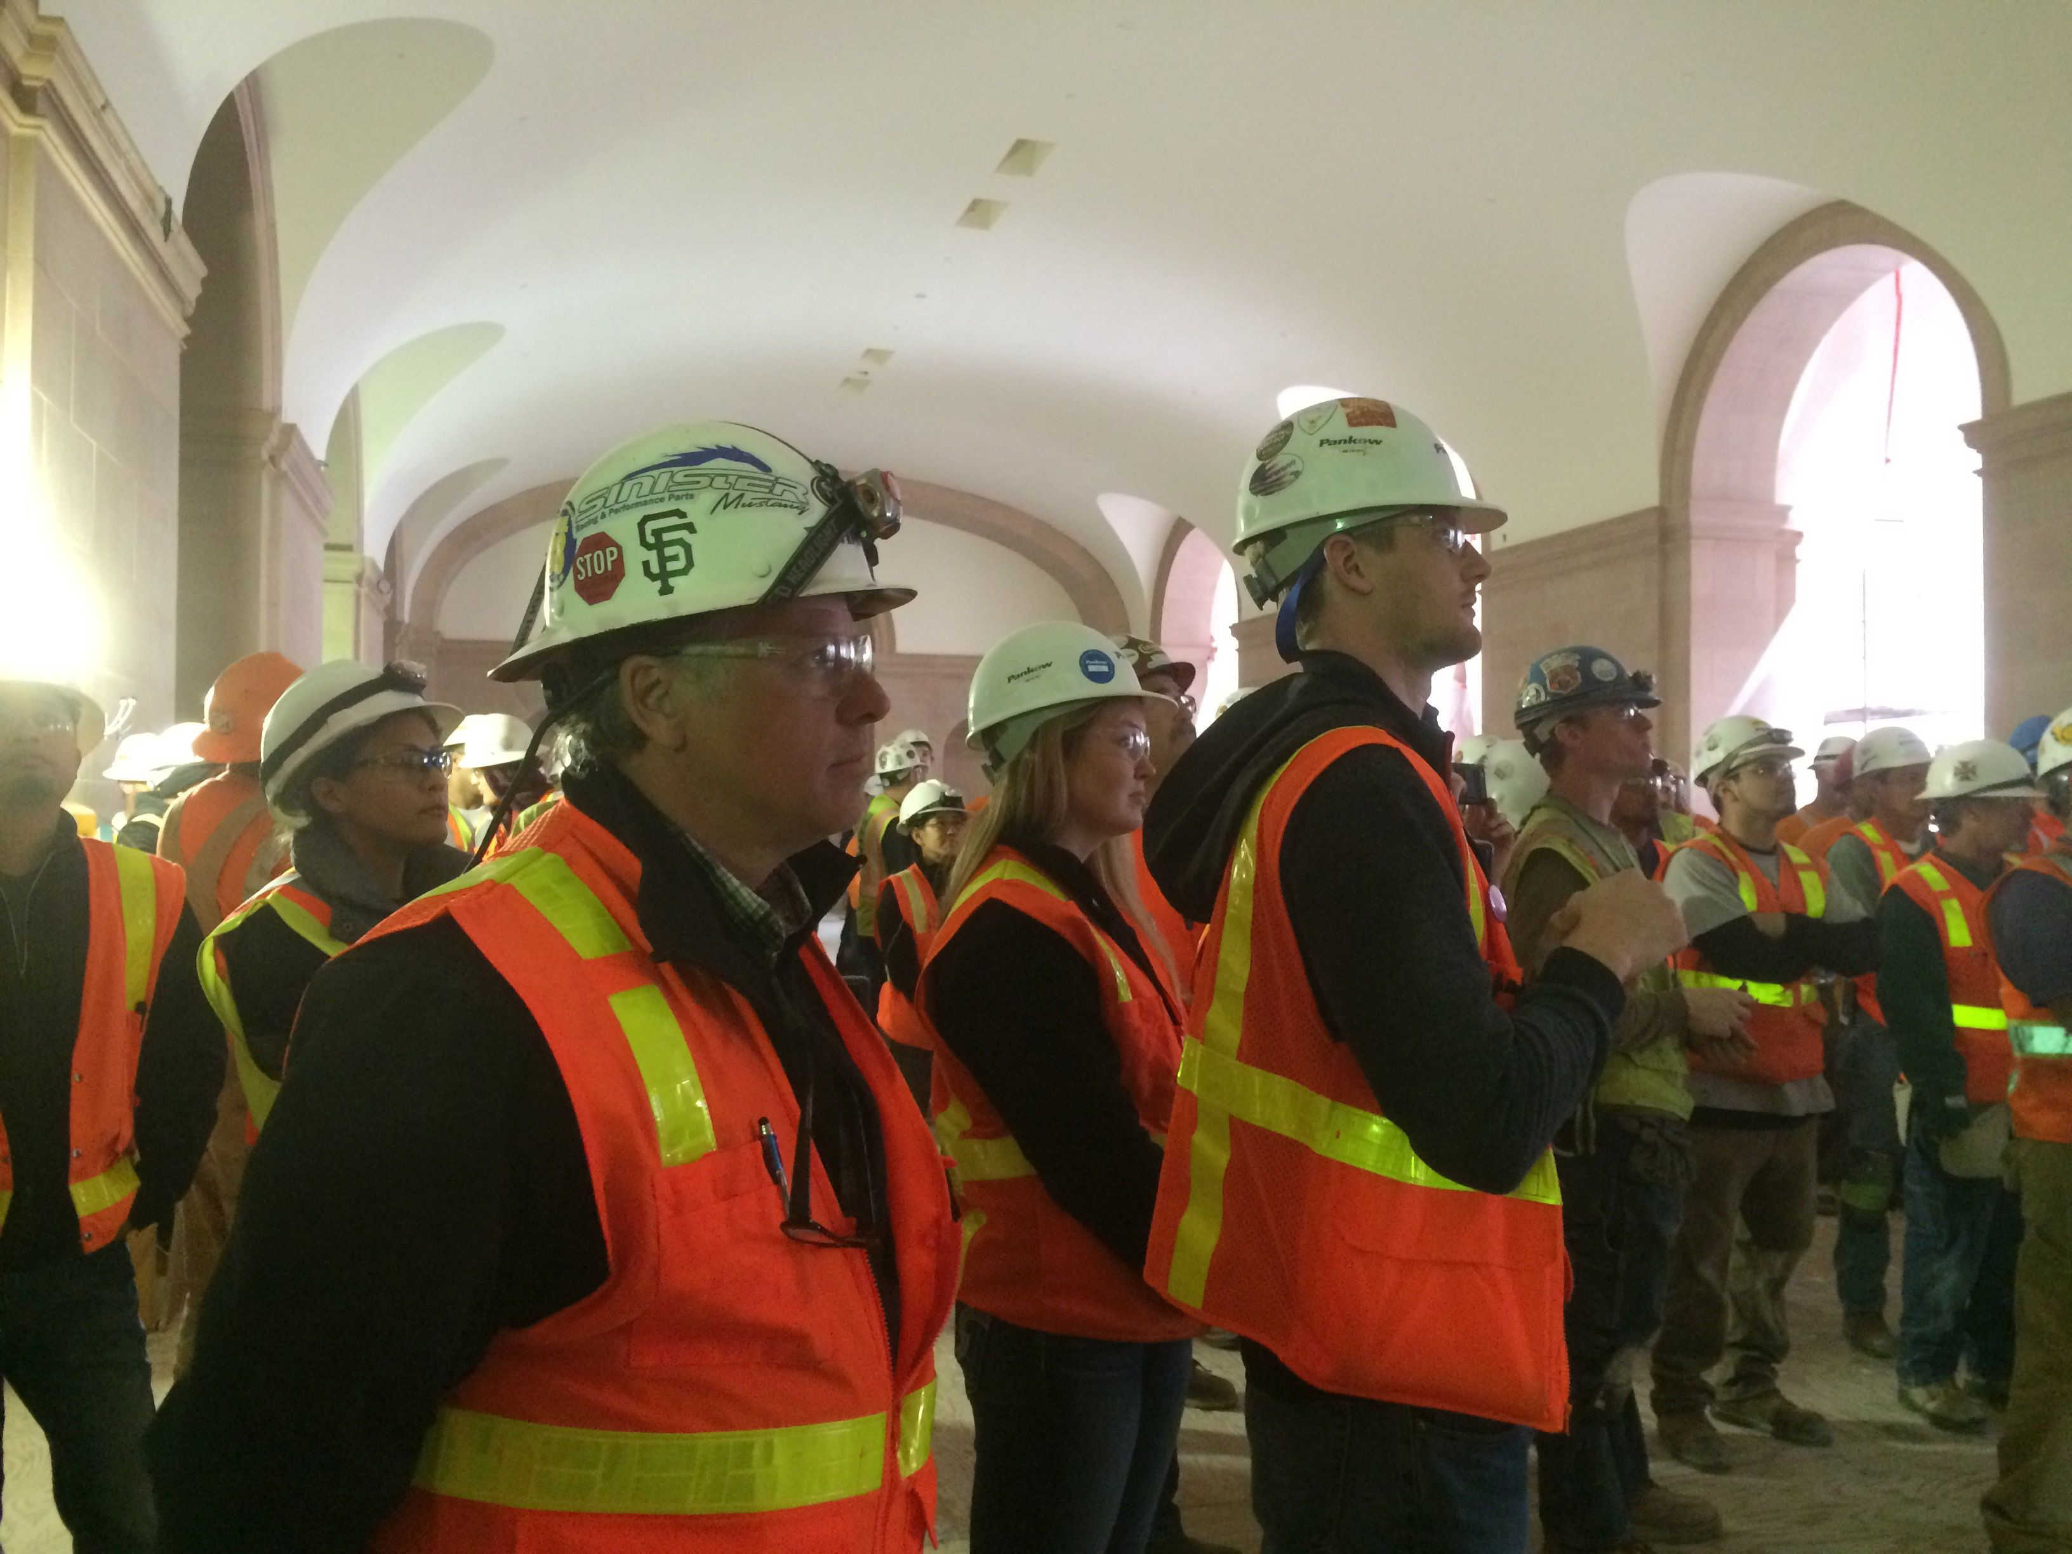

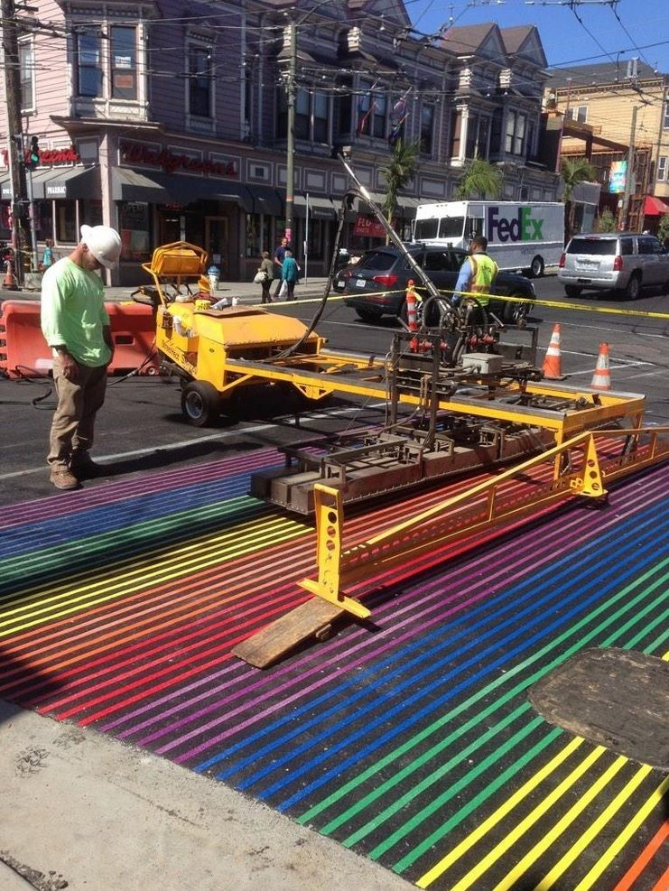

Rob Reaugh

Facilitator

925-487-2404

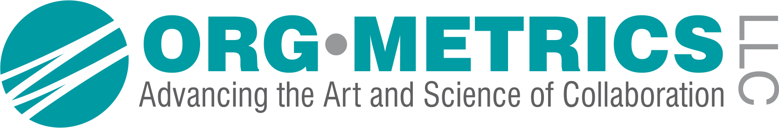

robreaugh@orgmet.com

**San Francisco Collaborative Partnering Steering Committee**

**Education & Training Subcommittee Meeting #7**

January 24, 2018

*As recorded on the flip charts*

ACTION PLAN AND FOLLOW-UP ITEMS

* 1. The subcommittee reviewed the new draft PEP 0.1.1 Partnering Field Guide and provided feedback. The updated Field Guide draft is included as an attachment to this report.

2.1 Rob will reach out to with City Departments to determine if he can get assistance with typesetting the final Partnering Field Guide.

EDUCATION AND TRAINING SUBCOMMITTEE FOLLOW-UP MEETINGS

**March 2, 2018 9:00am – 10:30am 3rd Floor Civic Center Conference Room #3074**

April 30, 2018 9:00am – 10:30am 3rd Floor North Beach Conference Room #3072

UPDATED PARTNERING ENHANCEMENT PROPOSALS

*The subcommittee discussed the content involved with the new San Francisco Partnering Field Guide. For PEP 0.1.1 Partnering Field Guide, they provided feedback on the Table of Contents.*

PEP 0.1.1 New Partnering Field Guide

|  |
| --- |
| **Success Factor 0.0: Program Level Guidance**  **Issue 0.1.1 Partnering Field Guide** |
| **Problem Statement and Current Practice**  Currently, City staff has access to a Mini Partnering Guide that was developed to supplement an “Introduction to Partnering” training offered in 2014 and 2015. Project teams often do not have a firm grasp on how to successfully set up partnering on projects and may be unfamiliar with the new tools and recognition program.   * How do we arm CMs, REs, PMs and project leaders with the tools to more effectively use partnering on City construction projects?   **Proposal 0.1.1 New Partnering Field Guide**  We will develop a new Partnering Field Guide that incorporates all the policies and practices developed so far by the SFCPSC. This guide will include best practices for partnering, guidance for setting up meaningful partnering sessions, and highlight the new awards and recognition program.  Discussion on 1/24/18:  *Team discussed first impressions of the new Partnering Field Guide – What is good? What is missing/could be improved? And, What is standing out to them?*  *What is Good?*   * Comprehensive * Field Guide (and teams) are not eliminating the contract, but they are advocating for fairness * Project Managers (PMs) should be leading the Partnering effort – the Construction Manager may be the driver for certain departments, but typically it is the PM * Great information – we tackled the key items in here * We like that this is a one-stop tool and previously we launched a half-backed concept * We like the joint-training concept * We need to benchmark this program somehow   *What is missing/could be improved?*   * People don’t read * We need to make it easy * We need to keep it fresh with an annual update * We need a contractor resources page * Specific Notes by Chapter: * Chapter 2: Partnering – Setting up the Process   + Allowance – can we have the allowance be $15,000 per year (rather than $15k total) for Level 2 projects, in case the team wishes to schedule follow-up partnering sessions?   + We will place the allowance and detail on the Partnering Levels in Chapter 2 so the teams can find it right away * Chapter 3: Structured Collaborative Partnering - Kicking off and following through   + Issue Resolution section – there is a lack of clarity around the triggering event of an issue being elevated * Chapter 4: Integrated Dispute Resolution – When things are not going well   + Red Flags for when to implement ADR processes are a little soft – we may need stronger examples than “Team has a repeated pattern of conflict” or “Subs are not showing up to the weekly meeting”, individually, these would not be grounds for calling Facilitated Issue Resolution * Chapter 5: Interdepartmental Projects   + Remove the Da Vinci quote – it doesn’t make sense   Ideas to make it better:   * We should develop a one-pager with highlights for setting up and kicking off the process * We need an Issue Resolution Flow Chart that demonstrates to the City and Industry staff how the Integrated Dispute System works * We need to update the General Conditions and bake in the Facilitated Issue Resolution Process * We need to train people up on it * We need to create a hot-linked web page with resources   Status:   * Rob will include all subcommittee updates into the Field Guide in preparation for sharing it with the SFCPSC on 2/22/18. * The SFCPSC will roll out the updated partnering specification, general conditions, policies and new Partnering Field Guide by 6/1/18.   *Note – see updated PEP 0.1.1 and the attached draft Partnering Field Guide |

WHAT’S STANDING OUT TO YOU?

* For this new Partnering Program, there is lots of information to digest
* The desired outcome is quicker issue identification and resolution – how do we get there?
* How do we create the culture we are hoping to achieve?
* How do we translate this to projects closing out more quickly and having no claims?
* We need to confirm that there is top-down commitment on this – the failure of partnering occurs with the CCO requests come in late and when leaders don’t sit with the team and make sure the outstanding issues get resolved

**ATTENDEES**



PARTNERING – A MEDIATIVE PROCESS

California Evidence Code

§ 1119. Mediation confidentiality

1119. Except as otherwise provided in this chapter:

(a) No evidence of anything said or any admission made for the purpose of, in the course of, or pursuant to, a mediation or a mediation consultation is admissible or subject to discovery, and disclosure of the evidence shall not be compelled, in any arbitration, administrative adjudication, civil action, or other noncriminal proceeding in which, pursuant to law, testimony can be compelled to be given.

(b) No writing, as defined in Section 250, that is prepared for the purpose of, in the course of, or pursuant to, a mediation or a mediation consultation, is admissible or subject to discovery, and disclosure of the writing shall not be compelled, in any arbitration, administrative adjudication, civil action, or other noncriminal proceeding in which, pursuant to law, testimony can be compelled to be given.

(c) All communications, negotiations, or settlement discussions by and between participants in the course of mediation or a mediation consultation shall remain confidential.

THANK YOU FOR LETTING ME BE OF SERVICE

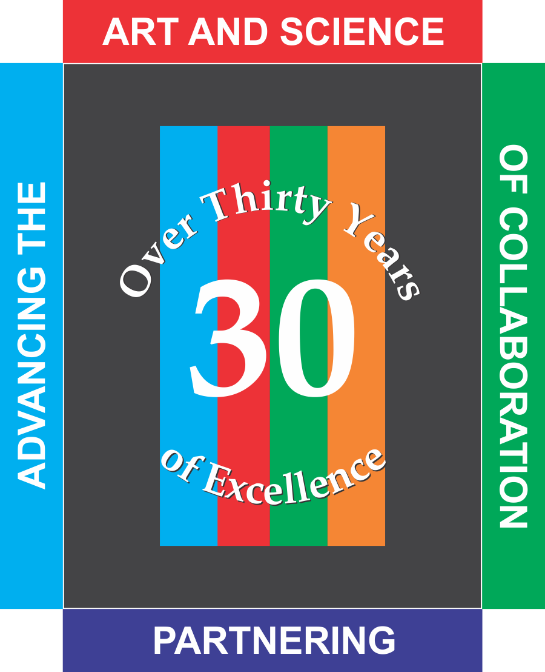ORG•METRICS LLC, celebrating its 30th year of service, works with construction teams who want to prevent or resolve disputes and with leaders who want to improve their organizations.

***Advancing the Art and Science of Collaboration!***

**ORG**•**METRICS**

291 McLeod Street

Livermore, CA 94550

Phone: (925) 449-8300

Email: robreaugh@orgmet.com

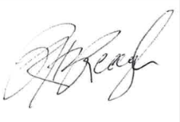Please call if I can help in any way

Rob Reaugh