San Francisco Collaborative Partnering Steering Committee
Education & Training Meeting #10 Report
August 23, 2018

San Francisco Municipal Transportation Agency
3rd Floor North Beach Conference Room
1 South Van Ness Ave
San Francisco, CA

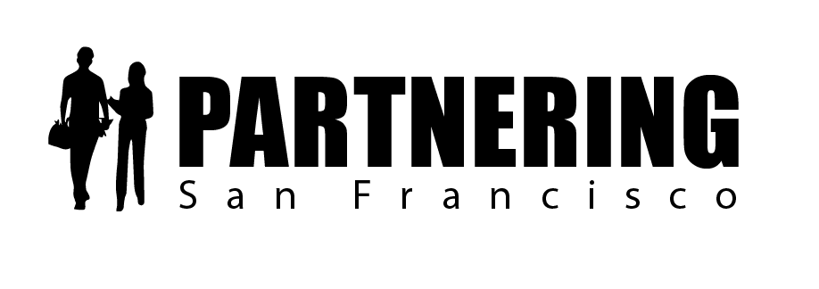

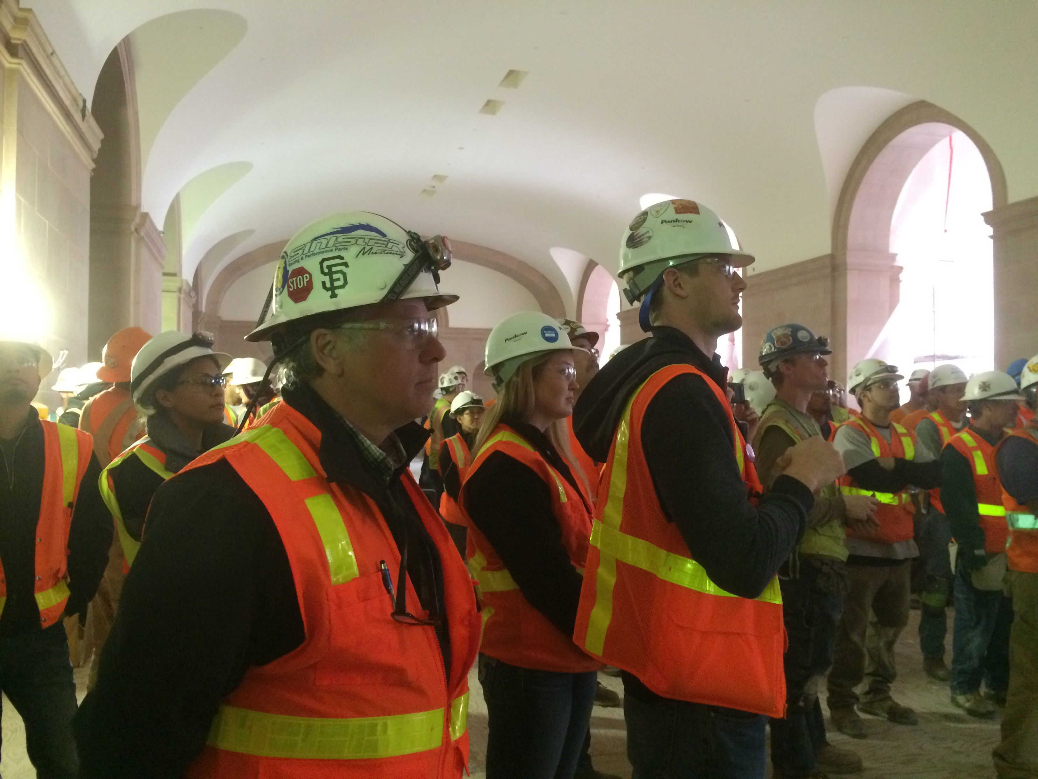
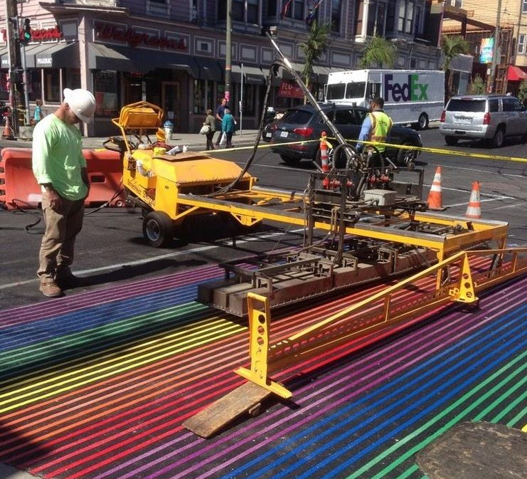

Rob Reaugh
Facilitator
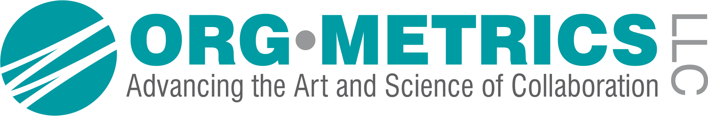925-487-2404
robreaugh@orgmet.com

San Francisco Collaborative Partnering Steering Committee
Education & Training Subcommittee Meeting #10
August 23, 2018

As recorded on the flip charts

ACTION PLAN AND FOLLOW-UP ITEMS

  - We will launch a Training Task Group this fall to vet the training content and support the marketing and launch of the partnering training by January 31, 2019.
Who: Rob will lead with Kevin Wagner, Mark Costanzo, and Uday Prasad

  - Rob will develop a draft Training Certificate.

2.1 Steve Rule will develop a draft Partnering Training Requirement intended for City RFP’s by September 7th (see below).
“In accordance with the Standard Citywide Partnering program, reference Specification Section 01 31 33, this project will involve Partnering as a Level X project. As required by the Partnering specification, at least one member of the awarded contractor’s team must have attended the City’s Partnering Fundamentals Training and have received, as evidence of successful completion, a Certificate of Completion from the training session. The intent is for the trained individual to be a key member of the project management team (the Project Executive, Project Manager or Project Superintendent is preferred). It is recommended that the contractor have at least two members of the team trained so that one is available to project at all times. Training is free and is offered monthly by the City. Attendance can be coordinated through the Partnering Coordinator and www.sfpartnering.com. Evidence of training (i.e. The Certificate of Completion) must be provided to the City’s Project Manager no later than 90 days after Notice to Proceed for the project has been issued.”

3.1 We will develop a draft registration roster made up of City and Industry staff who need to participate in the Partnering Fundamentals. We will also identify the individuals who have received the IPI Collaborative Partnering Orientation Training. (See Attachment 2)
Who: Rob

4.1 We will add a bonus point to the San Francisco Collaborative Partnering Awards 2019 Application for teams with at least two individuals who have attended the Citywide Partnering Training (See Attachment 3)

Follow-up dates:
October 10, 2018 1-2:30pm 3rd Floor North Beach Conference Room
November 29, 2018 1-2:30pm 3rd Floor North Beach Conference Room

UPDATED PARTNERING ENHANCEMENT PROPOSALS
The subcommittee discussed the updated General Conditions, the updated claims notification process and PEP 1.1.1 Partnering Training, which will be focused on the new San Francisco Partnering Field Guide.

Success Factor 1.0: Education and Training
Issue 1.1.1 Partnering Training – Signed with comments by SFCPSC on 6/7/18
Proposal 1.1.1 Partnering Training
We agree that a training program based on the new Partnering Field Guide should be developed. The training needs to be in-person, immersive and involve both City and industry staff. The training needs to be focused on the practical implementation of the new San Francisco Partnering Field Guide.

Discussion on 8/23/18:
The E&T Subcommittee reviewed PEP 1.1.1 and made recommendations to clarify the registration process, the logistics and database, the certification process, and how to ensure contractors attend the training.

Registration
- We need a staff person from the City to “own” the logistics for the training program
- We can use both an “online” Eventbrite registration system and identify an individual who will help get the City staff signed up for the training
- The database of certified individuals from Industry and City Departments could be maintained publicly on the www.sfpartnering.com/training website

Partnering Training Requirement
- We should not pursue bonus points for qualifications-based selection for contractors
- For draft RFP training requirement language see page 2, commitment 2.1.
- We need to mandate that teams submit partnering training certificates to the SF Partnering Coordinator within 90 days of NTP

Training Certification
- We need evaluation and feedback from the attendees – an open book test and/or an evaluation would satisfy this requirement
- Minimum one person from the owner and contractor’s team must be certified (See Attachment 4 - Sample Certificate)

Training Content
- We need to identify one executive from the SFCPSC who will kick off each training course
- We need to identify partnering champions for each training course. The champion’s role is to deliver the case-study and share a success story from an outstanding partnered project
  - Potential champions include: Internal Partnering Facilitators; Public Works: Michelle Woo, Albert Ko, Douglas Ullman, Simon Yeung, Samuel Chui; SFO: Kristen Allen and Tania Gharechedaghy
  - Idea: Develop a video from the Awards ceremony
- The intended training outcomes are:
  - Participants will understand the benefits of partnering, develop familiarity with the Field Guide, learn the new Matrix, understand the new partnering allowance, develop support and energy for partnering, learn how to develop the Charter, use the Issue Resolution Ladder, use Scorecards and understand the role of the partnering facilitator

Training Roll-out
- The subcommittee estimates 280 City staff and as many as 200 industry staff (Executive, PM, lead, foreman, superintendent) need to be trained (see PEP Roll-out plan for details).
- We plan to hold the kick off by January 31st – 25-30 people are needed to go through the course
- We will hold minimum one training per month in 2019 and train ~300 people
- Ideally have a mixture of City staff and contractors in each course
- We need to produce a sample invitation letter from the SFCPSC directors to launch the program

Payment for Trainer
- We plan to use As-needed contracts with Public Works, SFPUC, and others to fund the training.
- For SFPUC, they may be able to run the training under a larger project/program.

Status:
- Develop a roster of City Staff and Industry who have attended the Collaborative Partnering Orientation Training course - Completed
- Develop draft RFP language for the Partnering Training requirement – Completed
- Review the draft RFP language by October 10th
- We will confirm availability of funding for trainer Rob Reaugh through “As-needed” contracts through key entities including Public Works, SFPUC, and SFMTA by December 1st
- We will add a bonus to the 2019 San Francisco Partnering Awards Application for teams with members who have attended the Partnering Training (See Attachment 3)

*Notes: See Attachment 1 – Updated PEP 1.1.1 Partnering Training
See Attachment 2 – Registration Roster
See Attachment 3 – Updated Partnering Awards Application
See Attachment 4 – Draft Training Certificate

WHAT’S STANDING OUT TO YOU?
- Good progress by the subcommittee
- Champions for training need to be identified
- Success stories for the newsletter are needed

ATTENDEES

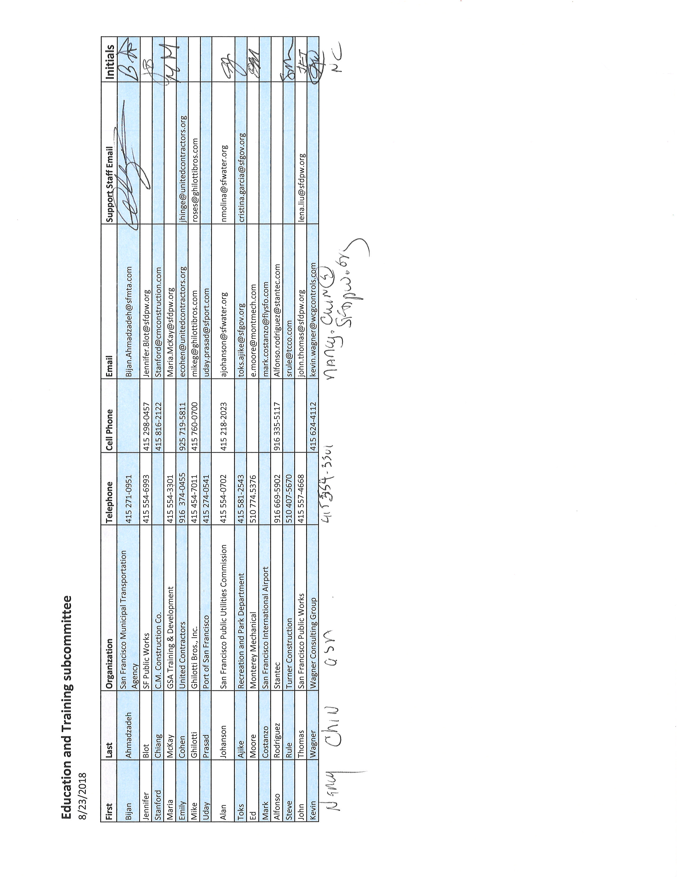

PARTNERING – A MEDIATIVE PROCESS

California Evidence Code

§ 1119. Mediation confidentiality

1119. Except as otherwise provided in this chapter:

(a) No evidence of anything said or any admission made for the purpose of, in the course of, or pursuant to, a mediation or a mediation consultation is admissible or subject to discovery, and disclosure of the evidence shall not be compelled, in any arbitration, administrative adjudication, civil action, or other noncriminal proceeding in which, pursuant to law, testimony can be compelled to be given.

(b) No writing, as defined in Section 250, that is prepared for the purpose of, in the course of, or pursuant to, a mediation or a mediation consultation, is admissible or subject to discovery, and disclosure of the writing shall not be compelled, in any arbitration, administrative adjudication, civil action, or other noncriminal proceeding in which, pursuant to law, testimony can be compelled to be given.

(c) All communications, negotiations, or settlement discussions by and between participants in the course of mediation or a mediation consultation shall remain confidential.

THANK YOU FOR LETTING ME BE OF SERVICE

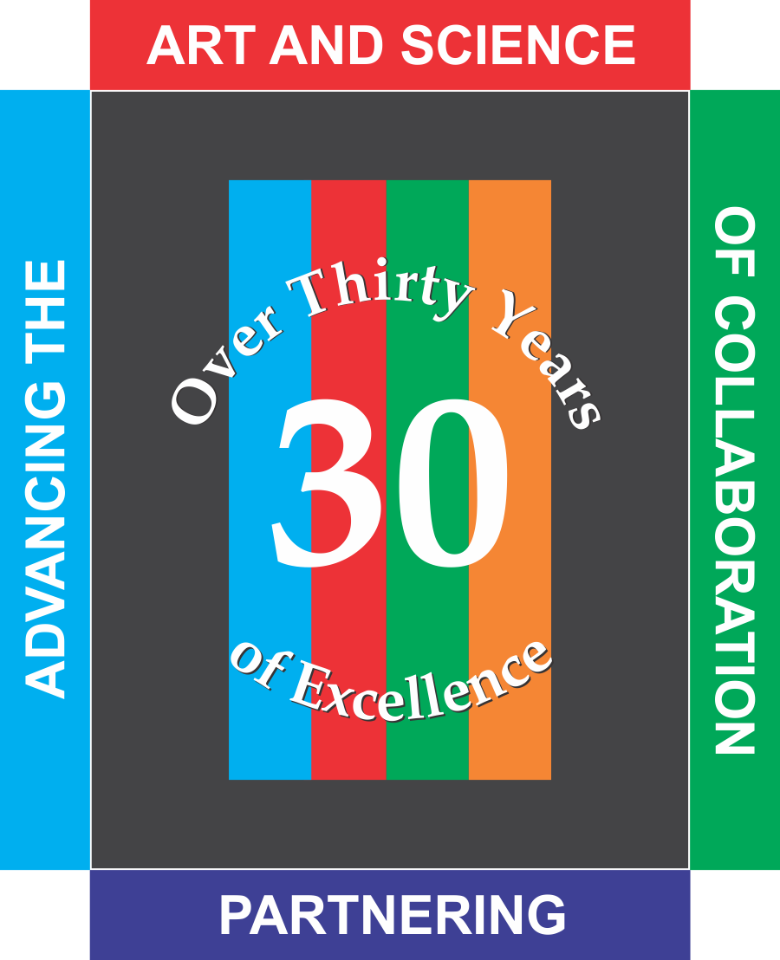
ORG•METRICS LLC, celebrating its 30th year of service, works with construction teams who want to prevent or resolve disputes and with leaders who want to improve their organizations.

Advancing the Art and Science of Collaboration!
ORG•METRICS
291 McLeod Street
Livermore, CA 94550
Phone: (925) 449-8300
Email: robreaugh@orgmet.com
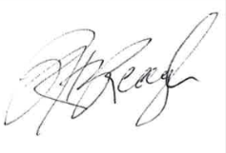
Please call if I can help in any way

Rob Reaugh

