San Francisco Collaborative Partnering Steering Committee
Performance Measures Subcommittee Report
Meeting #6
November 14, 2017

San Francisco Public Works
Main Conference Room
30 Van Ness Ave.
San Francisco, CA
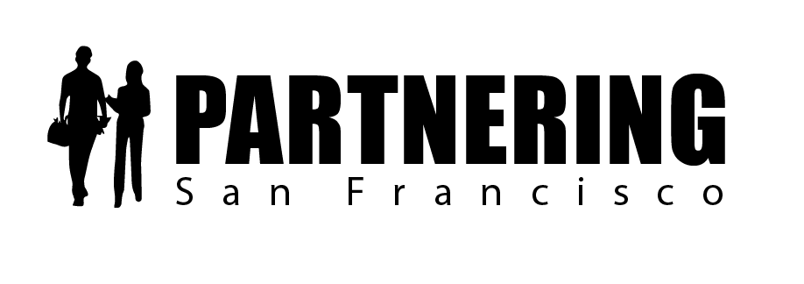

Rob Reaugh
Facilitator
925-487-2404
robreaugh@orgmet.com

San Francisco Collaborative Partnering Steering Committee
Performance Measures Subcommittee Meeting #6
November 14, 2017

As recorded on the flip charts

ACTION PLAN AND FOLLOW-UP ITEMS

1.1 Rob will distribute a calendar invitation (Doodle) to the subcommittee members by December 1st and establish the 2018 meeting schedule by December 15th.

2.1 We will update the draft San Francisco Citywide Bid Study results to highlight project bidding results by both department and delivery method. See PEP 2.3.2 Increase Number of Bidders – Addendum 1 for updated results. Please provide comments and initial findings to Rob by December 14th.

2.2 We will reach out to SFPUC to determine whether bidding results are available from May 2016 – March 2017, so the data set is more consistent.
When: By December 14th
Who: Rob to Alan and Mario

PERFORMANCE MEASURES FOLLOW-UP MEETINGS
All subcommittee meetings will be held in person at 30 Van Ness, main conference room
- Rob will distribute the Doodle calendar invitation by December 1st. He will finalize the 2018 meeting dates by December 15th.

UPDATING PARTNERING ENHANCEMENT PROPOSALS
The Performance Measures subcommittee discussed two Partnering Enhancement Proposals (PEPs):
PEP 2.3.2 Increase the Number of Bidders and PEP 2.3.2 San Francisco Partnering Awards (signed 10/10/17, with updates shared at meeting).

Performance Measures PEP
Issue 2.2.3 Increase Number of Bidders – PEP drafted for 11/14/17 subcommittee meeting
Barrier
Currently, we are not tracking bid results across all City departments. Departments need to make a stronger effort to coordinate the bidding schedule to make it easier for contractors to know which projects are being advertised.

Problem Statement and Current Practice
Construction in the Bay Area is extremely robust, and it is common knowledge that prices are escalating. To better understand the bidding climate, the SFCPSC developed a Bid Results Survey in July 2017. The City departments rarely track the number of bidders per project in a coordinated way. Also, each department advertises its projects independently, so the timing of contracts being let is not always optimized between departments. We would like to establish benchmarks for current bidding levels for each department and identify potential strategies to improve bid responses citywide.

- How can we establish benchmarks for bidding on projects in San Francisco?
- How can we determine the effect the busy construction market is having on bidding in San Francisco?
- How can we remove barriers to bidding on City projects?

Updated Citywide Bid Survey Results
The Subcommittee asked Rob to separate traditional Design-bid-Build project results from alternative delivery methods (i.e. D/B and CM/GC). For detailed results, please see PEP 2.3.2 Addendum I.

Discussion
- Subcommittee asked for a revised bid results survey (See Addendum I), which separates projects by department and delivery method to provide an “apples to apples” comparison.
  - Traditional Design-Bid-Build (D/B/B) projects are bid by the general contractor and represent most projects citywide.
  - SFO uses Progressive Design-Build (D/B) and Construction Manager/General Contractor (CM/GC) delivery methods – in these delivery methods the general contractor self performs less than 7.5% of the contract and the rest is bid directly to subcontractors.
- All bids are compared to engineer’s estimates as the baseline. There are concerns about the validity of engineer’s estimates because they may not consider all market forces or the final design, but it is a common industry practice nevertheless.
- Rob will reach out to SFPUC in hopes that we can obtain the full bidding history since mid-2016.
- Rob and Jen will share updated initial findings with the PM Subcommittee in January 2018.
- Notes on estimating:
  - For Public Works, teams use a professional estimating service. For many years, estimators assumed a total of 3-5 bidders; today estimators have been instructed to assume 1-2 bidders.
  - Public Works is moving to online bidding, which will ideally result in fewer clerical errors.
- Bid scheduling:
  - The SFCPSC brought up the concern that multiple departments could be releasing similar scopes at the same time – though an analysis of this data set revealed that this was very uncommon, and typically, industry alerts the departments when it occurs, so they can move the dates around. It is more common for a single department to release two similar packages at the same time.
  - The PM Subcommittee recommends that we remove the issue from the PEP.

Subcommittee discussed ideas to improve City bidding results
- For small businesses (LBEs and SBEs)
  - Idea 1: Develop FAQs on invoicing or 10 most common bidding errors by small businesses on City projects
  - Idea 2: Mentorship – Formalize mentorship model for GCs – on large projects, the GCs are mentoring the admin staff from LBEs and SBEs to ensure they are invoicing properly (SFO, Warriors project)
  - Idea 3: Survey – Create a survey asking small businesses about common barriers to bidding in the City
    - Romulus Asenloo (CMD) may have ideas regarding trends or a pool of survey responders
  - Idea 4: Expand on the SFPUC Small Business Training Center services
    - Improve City Contracts Help Line – frequently, when small businesses contact City with bidder’s inquiries, the person answering the phone doesn’t know construction and therefore is not helpful
    - Provide a debrief for contractors who lose a bid
    - Learn what Port of Oakland has done to improve its process recently
- Idea 5: Improve Bidding Websites/Communication
  - Develop/broaden implementation a single citywide bidding website used by all departments
  - Develop an email newsletter that announces all department bids by trade
  - Place all City departments’ bid links websites on www.sfpartnering.com

Note: See Attachment #1 for Draft PEP 2.3.2 Increase Number of Bidders and Addendum I – Updated Citywide Bid Results Study

Performance Measures PEP
Issue 2.3.2 San Francisco Project Partnering Awards – PEP signed 10/11/17
PEP 2.3.2 San Francisco Project Partnering Awards
Implementation Updates
- Awards Subcommittee was launched and will be co-chaired by Jennifer Blot and Kevin Wagner
- First Subcommittee meeting was on November 13th
- Award application deadline will be June 30, 2018 – for the first year, projects that were substantially completed between January 1, 2016 and December 31, 2017 will be eligible
- Ceremony is planned for September – considering a dinner program
- Judging committee – five judges will be selected based on nominations and interviews – they will need to develop plan regarding conflicts of interest
- Application to be launched March 1, 2018

Note: Visit www.sfpartnering.com for current awards application draft

ONGOING PEPS
The Performance Measures Subcommittee has two other PEPs in process, which were not discussed on November 14^{th:} PEP 2.3.1 San Francisco Partnering Champions and PEP 2.2.2 Reduce Claims/Potential Claims

Performance Measures PEP
Issue 2.3.1 San Francisco Partnering Champions
Problem Statement and Current Practice
There is no forum to recognize project teams that are successfully using partnering to improve project outcomes as the project progresses.
- How do we recognize construction project teams that are using partnering successfully as the projects are being built?

Proposal
We will develop a “Partnering Corner” for each City department. Project teams who have either successfully demonstrated effective partnering or done something notable through collaboration may be nominated for a Project with Outstanding Partnering (POP) recognition. Each of the City departments will determine the best forum - newsletter, website, blog, etc. - to host the Partnering Corner updates and accolades.

We will create a Partnering Corner for San Francisco publications that can be used in each of the six City Department Newsletters.
- Public Works – “In the Works”  - Port of SF – “@SFPort”  - Recreation and Park Department – “Rec and Park News Blog” | - SFMTA – “SFMTA News Blog”  - SFO – “SFO Update or SFO Connect”  - SFPUC – “SSIP Newsletter”

*Note: See Attachment #3 for updated Draft PEP 2.3.1 San Francisco Partnering Champions

Performance Measures PEP
Issue 2.2.2 Reduce Claims/Potential Claims
Barrier
There is currently no City system for monitoring ongoing projects for potential claims, stop notices, and other indicators that issues are not being resolved by the team.

Problem Statement and Current Practice
It is not well known how City departments are monitoring ongoing construction issues that could become potential claims. There are currently no established benchmarks related to notices of potential claims (NOPCs), stop notices, use of processes like Dispute Review Boards (DRBs), Dispute Review Advisors (DRAs), or other indicators that a team is struggling to resolve issues during construction.

- How can we establish benchmarks for potential claims (NOPCs), stop notices, and the use of DRAs and/or DRBs (if applicable)?
- How can we measure NOPCs, stop notices, the use of DRBs or DRAs, etc. at the project level?

*Note: See Attachment #4 for Draft PEP 2.2.2 Reduce Claims/Potential Claims

FINAL DISCUSSION – PEP REVIEW FOR THE NEW PARTNERING FIELD GUIDE
- Edgar and Jennifer developed a Citywide task group focused on adapting the language of the Partnering Enhancement Proposals into City language. The first meeting is on November 14th and they will be reviewing the previously signed PEPs, focusing on amending the language of the draft partnering specification
- On October 11th, the SFCPSC agreed to update PEP 2.1.2 Partnering Spec Thresholds
  - To finalize the PEP, the task group needs to clean up the language related to partnering payment and partnering allowances – SFCPSC agreed that the allowance should cover all the partnering costs
  - The partnering specification also needs key revisions based on the newly-signed Partnering Enhancement Proposals
  - The partnering specificiation can also be reduced in length if the definitions section can be shifted to the new Partnering Field Guide
- Public Works has been spearheading an update of the General Conditions and has reviewed between 40 and 50 lines
- Once the partnering specification is finalized, the departments will need to update the General Conditions

ATTENDEES

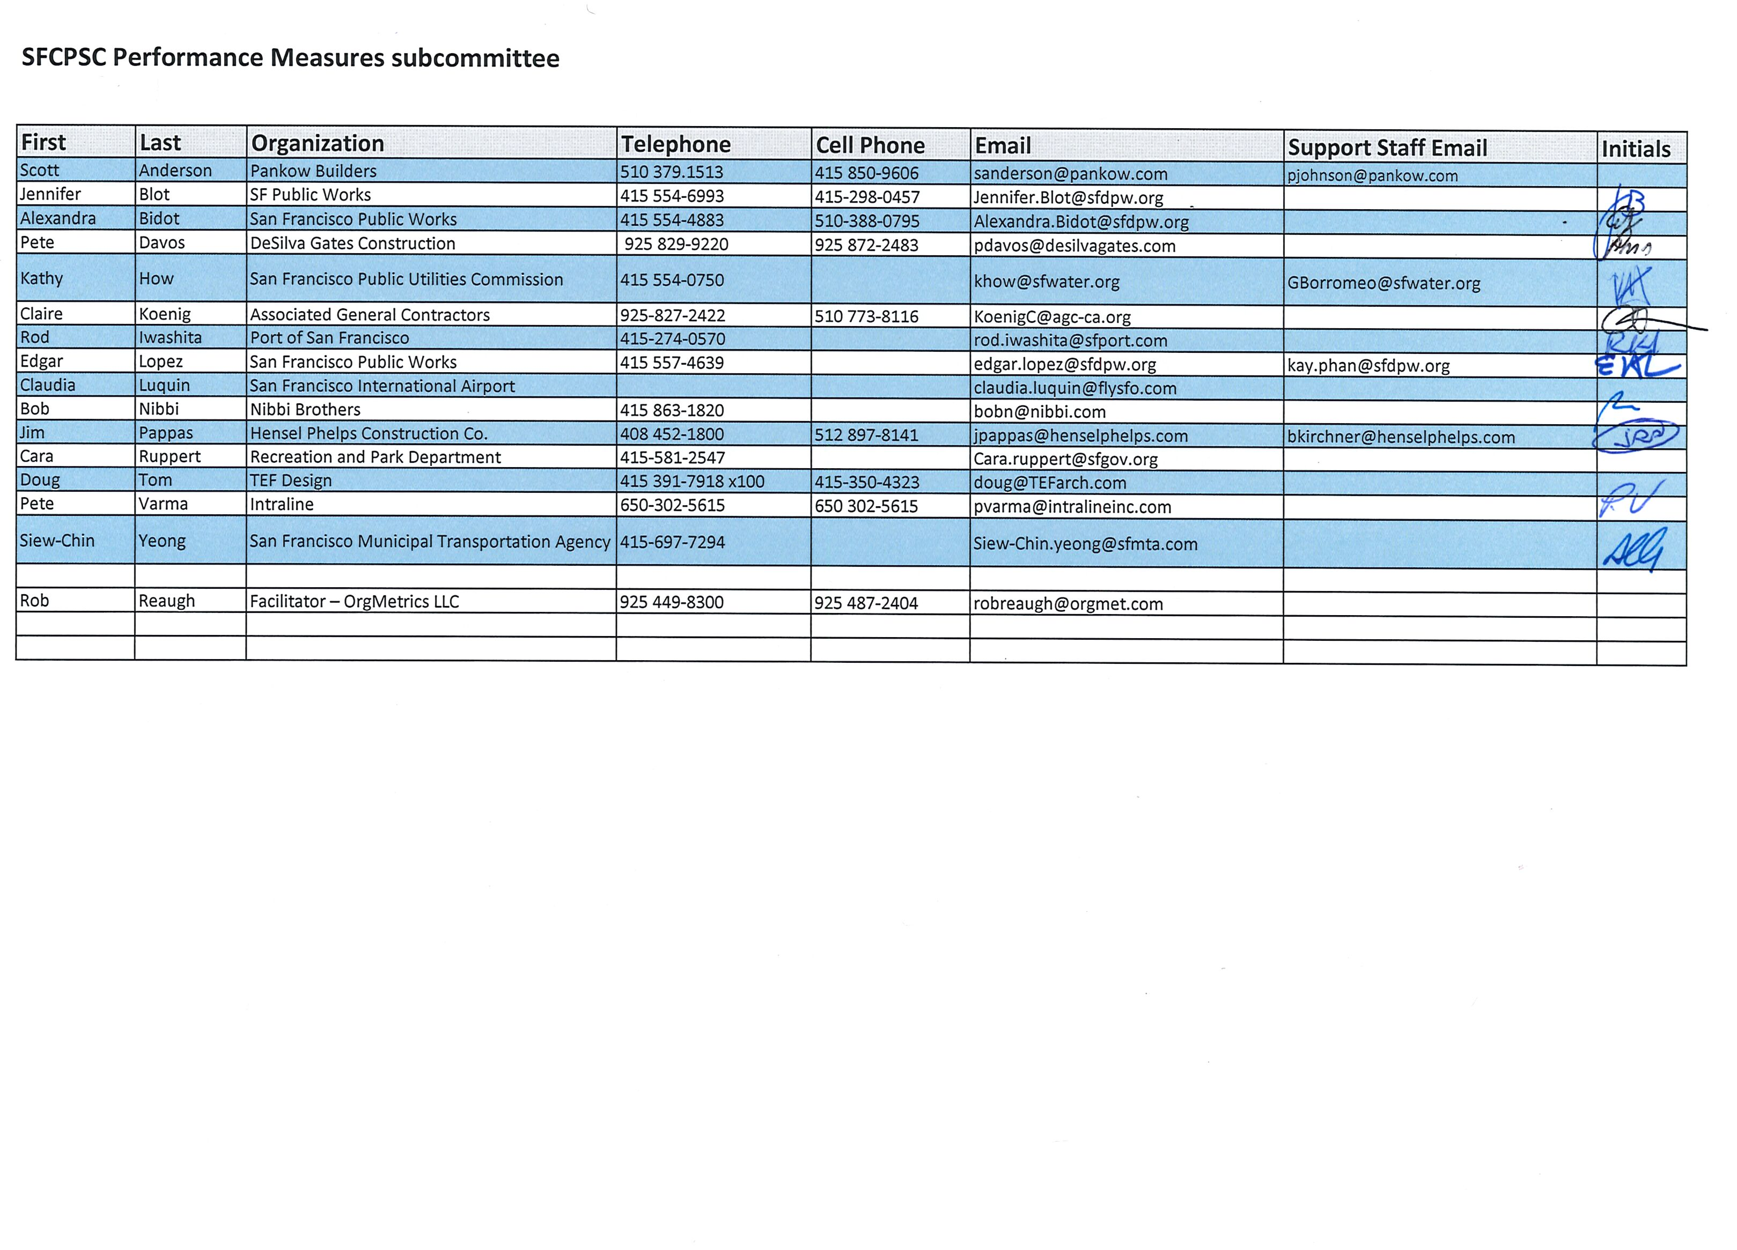
PARTNERING – A MEDIATIVE PROCESS

California Evidence Code

§ 1119. Mediation confidentiality

1119. Except as otherwise provided in this chapter:

(a) No evidence of anything said or any admission made for the purpose of, in the course of, or pursuant to, a mediation or a mediation consultation is admissible or subject to discovery, and disclosure of the evidence shall not be compelled, in any arbitration, administrative adjudication, civil action, or other noncriminal proceeding in which, pursuant to law, testimony can be compelled to be given.

(b) No writing, as defined in Section 250, that is prepared for the purpose of, in the course of, or pursuant to, a mediation or a mediation consultation, is admissible or subject to discovery, and disclosure of the writing shall not be compelled, in any arbitration, administrative adjudication, civil action, or other noncriminal proceeding in which, pursuant to law, testimony can be compelled to be given.

(c) All communications, negotiations, or settlement discussions by and between participants in the course of mediation or a mediation consultation shall remain confidential.

THANK YOU FOR LETTING ME BE OF SERVICE

ORG•METRICS LLC, celebrating its 30th year of service, works with construction teams who want to prevent or resolve disputes and with leaders who want to improve their organizations.

Advancing the Art and Science of Collaboration!
ORG•METRICS
291 McLeod Street
Livermore, CA 94550
Phone: (925) 449-8300
email: robreaugh@orgmet.com
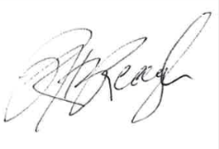
Please call if I can help in any way

Rob Reaugh

