San Francisco Collaborative Partnering Steering Committee
Performance Measures Subcommittee Report
Meeting #14
May 7, 2019

San Francisco Public Works
4th Floor - Main Conference Room
30 Van Ness Ave.
San Francisco, CA
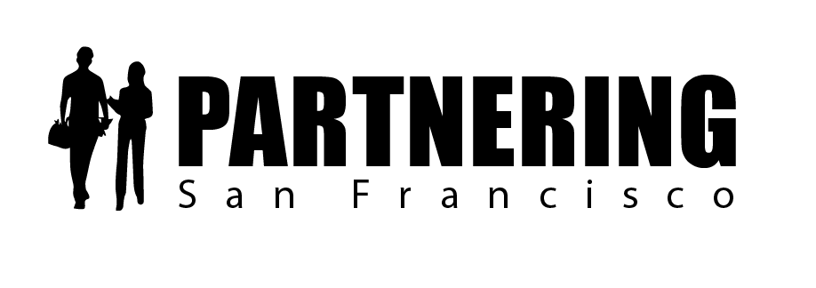

Rob Reaugh
Facilitator
925-487-2404
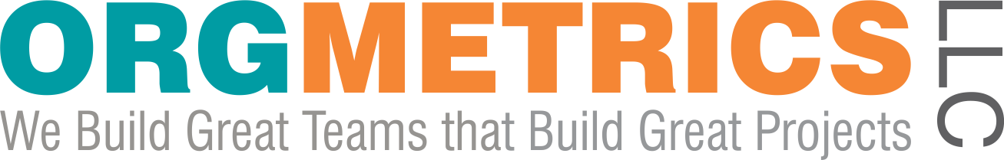
robreaugh@orgmet.com

San Francisco Collaborative Partnering Steering Committee
Performance Measures Subcommittee Meeting #13
May 7, 2019

As recorded on the flip charts

ACTION PLAN AND FOLLOW-UP ITEMS

Item 1: Claims Benchmarking Survey (PEP 2.2.1)
1.1 We will provide the Claims Benchmarking results to Jen and Rob by May 22nd.
See Attachment 1 for details.
Public Works – Alexandra and Jennifer
Rec & Parks – Levi, Reem and Toks
Port - Uday and Rod (Port)
SFPUC – Completed
SFO – Completed
MTA – Completed

Item 2: Safety and Partnering (PEP 2.4.1)
2.1 We will develop a sample safety slide to share with City Internal Partnering Facilitators that includes craft hours, lost time incidents and an accounting of near miss incidents.

2.2 We will develop a sample OAC/Weekly Progress Meeting minutes with an accounting of safety record.

Upcoming SFCPSC Meetings and Deadlines
- Contractor Liaison Meeting is June 4, 2019, 8:30 am
- Full SFCPSC Meeting #10 – June 7, 2019 – 9:00am – 11:30am
- SF Collaborative Partnering Awards applications are due June 28, 2019!
- SF Collaborative Partnering Awards Ceremony is September 26, 2019 – 9:00am – 11:00 am
San Francisco Marines Memorial Club and Hotel

CITY ATTORNEY EDITS TO THE PARTNERING SPECIFICATION
The PM Subcommittee reviewed and discussed the edits made to the Partnering Specification and the Partnering Field Guide by the City Attorney.

Discussion:
- PM Subcommittee members would like to know more about the new Article 3.6 in the Partnering Spec, titled “Termination of the Partnering Process,” and what the objective of the article is.
- The MTA recommended additional clarifying language about how partnering does not affect the timing of filing the NOPC or the government code claims.
- Department Directors are planning to meet to review and finalize the specs and field guide
- Field Guide Training will resume beginning on May 30th

PEP 2.4.1 SAFETY AND PARTNERING
The PM Subcommittee discussed one Partnering Enhancement Proposal, PEP 2.4.1 Safety and Partnering.
Discussion:
Nicolas King (Public Works) and his team have launched task groups focused on six elements of Safety. The mission is to nurture the culture of safety for employees and the private contractors delivering projects in CCSF. Six topics are being explored:
  - City Employee Health and Safety Practices
  - Safe Practices on site
    - Any proposals will be mindful of allowing for contractor means and methods
    - Detailing safety requirements for hazardous conditions
  - Legislation – sample legislation is being proposed to amend safety criteria
  - Bid Process and Pre-Qualifications
    - The criteria for the safety spec are that it a) needs to be fair and b) have the appropriate method for measurement
    - The feedback has been that EMR is not the preferred methodology, particularly for small contractors
Proposal:
      - Have builders read the proposed safety spec it and provide feedback
      - Include clarity on who provides daily inspections and weekly reports, identify who reviews the mandated Safety Monitor
      - Vet that inspector cannot direct the contractor’s practices and determine how to intervene when there is a disagreement over a practice that is not deemed safe by the inspector.
  - Best practices
    - Existing specifications are general and require a 30-hour OSHA safety training for the Safety Manager
      - Moving forward, City specs will require an independent and certified designated safety person to provide oversight on projects
      - Team needs to level-set expectations for what is considered “safe” work
  - Oversight body – City Controller’s office and Board of Supervisors oversee the program
    - The investigation was initially launched per the Board’s request – there have not been ongoing requests since the initial inquiry

Ideas to improve Safety on Partnered Projects
Idea 1: Assemble a Task Group/Contractors Forum
- Discuss barriers and opportunities for improvement for an updated safety spec with a small group of City contractors
- Discuss a fair system for establishing safety criteria (other than EMR) to support best-value selection practices

Idea 2: Connecting Safety to Partnering sessions
- Develop a sample slide for accounting for craft hours, lost time incidents, and near misses.
- Develop expectations that teams will share lessons learned when there is an incident or near miss.
- Use the IRL when attempts to resolve safety issues are not being handled effectively at the field level.

Idea 3: We need to gather program-wide best practices for safety and partnering
- Develop Key Performance Measurements:
  - Measure and report on recordable incident rate for both contractors and City staff
  - Measure and report on near-miss rate
  - Encourage an environment where the team discusses any near misses openly and applies time to learn lessons.
  - This culture must be demonstrated by the owner – that each near miss is a teachable moment, rather than a “gotcha” for the project team
- Develop ways to track safety in the weekly progress meeting minutes or monthly reports and develop samples
- Gather key safety officers and share best practices and also what doesn’t work well
  - PUC has an in-house safety monitor for the Program Management team (one person who keeps track) – Alan can designate someone
  - Port has a safety hygienist who does construction safety plans and reviews for the CM team
  - Develops a Quality Actions Issues list that tracks safety performance
  - SFO – Includes information in monthly reports and in the OAC meeting minutes. Also uses Partnering as a forum to discuss and elevate recent safety incidents
  - Teams also typically set safety goals: 0 Lost Time incidents and/or a target rate for safety incidents (i.e. T1C and BAB set goal of ½ 1.5 LTI rate).

Barriers identified so far by the Safety Implementation Task Forces:
- These are new policies and staff have been resistant to change
- There are lots of departments with difficult work, so what works for one type of project may not work for others
- We need to identify and communicate best practices
- Safety became a political hot button with the Board of Supervisors – this can impede progress
- We need to foster an environment where we can review safety lapses without blame

Item #2: Safety and Partnering
2.1 We will develop a sample safety slide to share with City Internal Partnering Facilitators that includes craft hours, lost time incidents and an accounting of near miss incidents.

2.2 We will develop a sample OAC/Weekly Progress Meeting minutes with an accounting of safety record.
POTENTIAL SAN FRANCISCO COLLABORATIVE PARTNERING AWARDS NOMINEES
Projects must be substantially or finally completed between July 1, 2018 and June 30, 2019, complete minimum 2 partnering sessions and apply by June 28, 2019.
SFPUC
- Mountain Tunnel Winter Shutdown
- Moccasin Dam Emergency
- Calaveras Dam
- Sunol
- Powdered Activated Harbor
- Hetch Hetchy – AnVil
- Green Infrastructure
- South East Plant Project – Primary and Secondary Upgrades
- Digester Gas Project
SFO
- Long Term Parking Garage 2
SFMTA Potential Projects
- Twin Peaks
- Bird Facility
- Carl Divide Feeder
- Van Ness APCS Wiring
- UCSF Platform
- Fall Protection
- Tank Upgrades
- Subway Escalators
Port of San Francisco
- Backlands Improvement Project
Public Works
- Jen, Albert and Ed will provide recommendations
Recreation and Parks
- Golden Gate Park Oak Woodlands Trails Project
WHAT’S STANDING OUT TO YOU?
- Excited to get help with the safety initiatives
- There is SO MUCH work to do
- It is helpful to see in the big picture that leadership is committed
- Good discussion today
- We need a review of what we have been working on to kick-off the meeting for context – there is so much going on and we meet infrequently enough, that we need to get reacquainted with the materials each time

ATTENDEES
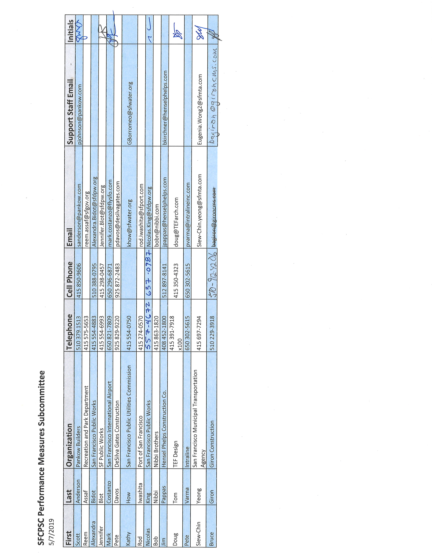
PARTNERING – A MEDIATIVE PROCESS
California Evidence Code

§ 1119. Mediation confidentiality

1119. Except as otherwise provided in this chapter:

(a) No evidence of anything said or any admission made for the purpose of, in the course of, or pursuant to, a mediation or a mediation consultation is admissible or subject to discovery, and disclosure of the evidence shall not be compelled, in any arbitration, administrative adjudication, civil action, or other noncriminal proceeding in which, pursuant to law, testimony can be compelled to be given.

(b) No writing, as defined in Section 250, that is prepared for the purpose of, in the course of, or pursuant to, a mediation or a mediation consultation, is admissible or subject to discovery, and disclosure of the writing shall not be compelled, in any arbitration, administrative adjudication, civil action, or other noncriminal proceeding in which, pursuant to law, testimony can be compelled to be given.

(c) All communications, negotiations, or settlement discussions by and between participants in the course of mediation or a mediation consultation shall remain confidential.

________________________________________________________________________________________________________

THANK YOU FOR LETTING ME BE OF SERVICE

We exist to build great teams that build great projects.

OrgMetrics LLC
291 McLeod Street
Livermore, CA 94550
Phone (925) 449-8300
email: robreaugh@orgmet.com
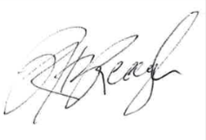
Please call if I can help in any way,
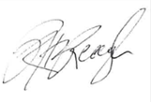
Rob Reaugh
______________________________________________________________________________
Visit www.ConstructionDreamTeam.com to listen to our podcast!
Podcast Launches January 7, 2019
www.ConstructionDreamTeam.com
Interviews with Industry Leaders about the people side of construction.
